EVENT LISTNERS:

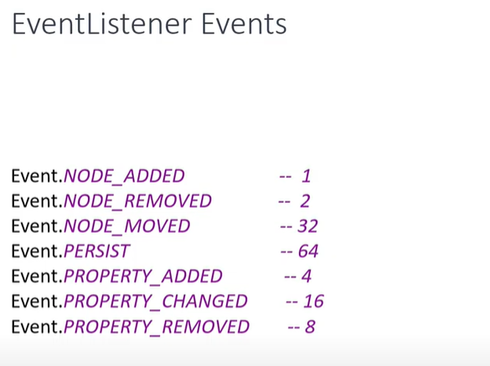

.

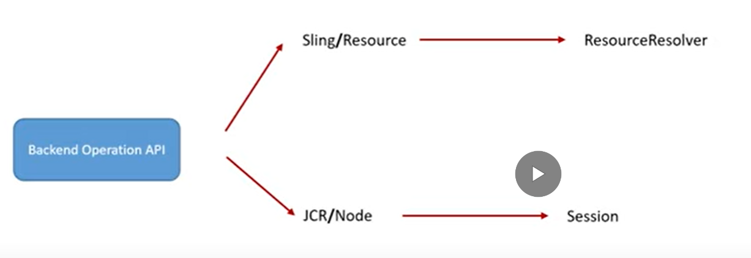

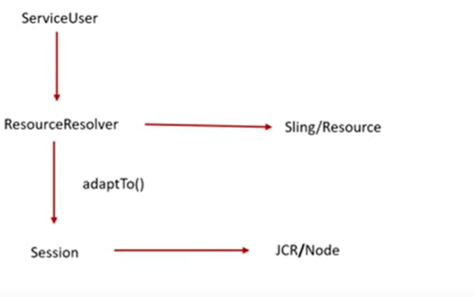

🡪From getworkspace() you will get getobservation() from getobservation you will add the addEventListener()

🡪Iterator contain event of all nodes,if one page is created multiple nodes created like cq:page , jcr:primarytype

🡪The **onEvent** method is called by the ‘’observation manager’’ when events of interest occur.

